Neuro-shell Trader (NST) Setup
for BGC TC Data Pump and Trade Pump

Date : 03 Jun 2008
Version : 1.0.0
Customer : www.tradecompanion.co.uk
Contact Person : Franco Dimuccio ( sales@tradecompanion.co.uk )

Install Neuroshell Trader 5.4 in “C:\NeuroShell Trader 5\” and Trade Companion (TC) in “C:\Program Files\BGC” the default directory. Only Tick data feeds for forex symbols will be sent by Trade Companion to Neuroshell. Symbols from other category, like Stock etc., is not supported by TC.

Required files for Data Pump.

Copy all the files from “C:\Program Files\BGC\BGC TradeCompanion\NST\Data Pump” to “C:\NeuroShell Trader 5\Servers“.

Required files for Trade Pump.

Copy all files from “C:\Program Files\BGC\BGC TradeCompanion\NST\Trade Pump” to “C:\NeuroShell Trader 5\BrokerageServers”.

Settings required in Neuroshell:

Data Pump:

When you first time run NST it will ask you for setting up “Data Source” if you missed this just go to Tools
---- Data Sources… as shown in image below.

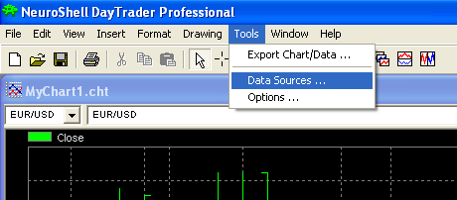

This will open a dialog box as given below:

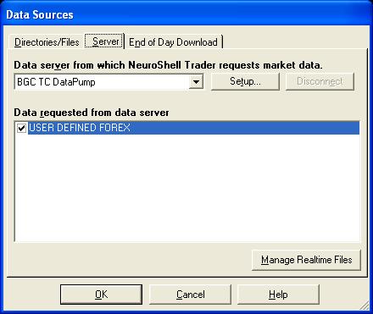

On ‘Server’ tab, select ‘BGC TC DataPump’ from the Drop down box. Check the check box in Data requested from Data Server Section. On Setup button just enter any values for username/password and on TimeZone tab select “Eastern time”. Click “Ok” button to close dialog box.

Trade Pump:

To setup for Trade Pump, go to
Tools
------Options……… as shown in image below.

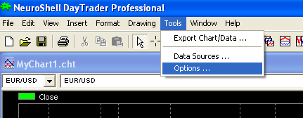

This will open a dialog box as given below:

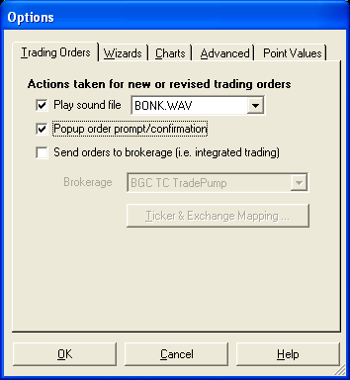

On Trading Option tab select “send order to brokerage” check box and select the brokerage as ‘BGC TC TradePump’. Click ‘OK’ to close the dialog box.

For automatic trading uncheck “Popup order prompt/confirmation”

Creating Charts:

For creating chart, click on the
File
---Scan for the ticker. As shown in image given below.

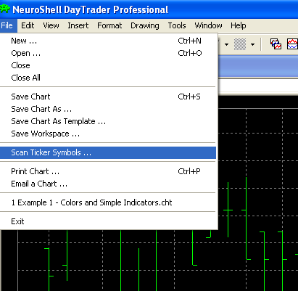

This will open dialog box as given.

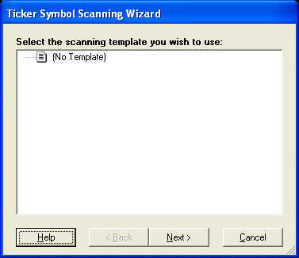

Select ‘No Template’ and press ‘Next’. Here select ‘Intraday, 10 Tick Bars as shown below.
Remember TC sends data for only tick bar. Press ‘Next’
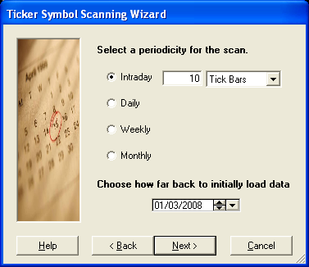

Select forex and Press ‘Next’.

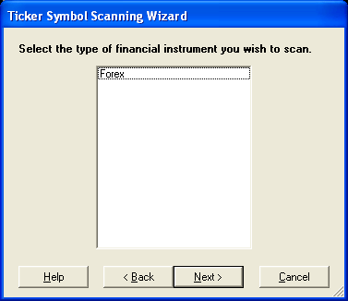

It will display the list of the symbols. If you want to create chart for the symbol not exist in list.

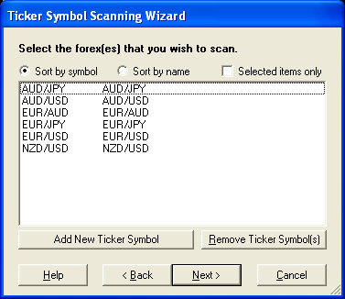

Click add new ticker. This will open ‘Add New Ticker’ Dialog. Fill ticker, name and select category ‘Forex’. Press ‘OK’ will add new ticker to the list. You can also remove ticker by pressing remove ticker Button. Adding a new ticker will show a dialog box as shown below

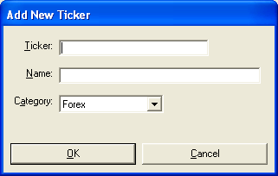

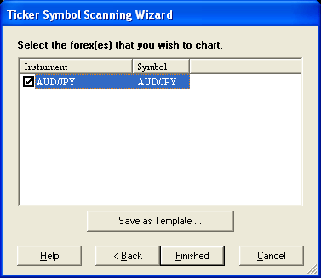

Select all the check box for the instruments displayed. Click ‘Finished’ to create charts.

Applying Strategy:

In ‘Insert Menu’ select ‘New Trading Strategy…’ will open the dialog box.

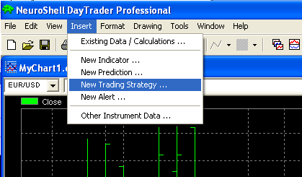

As shown here……
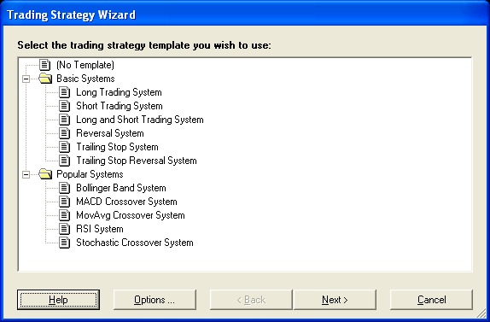

Select any strategy and press ‘Next’ thrice. Then press ‘Finished’ applying the strategy.
Now click view -→ Alerts and Orders window

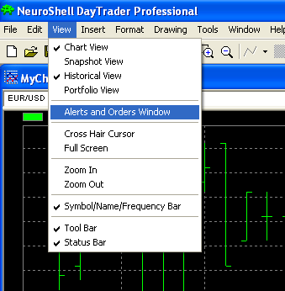

Will open dialog box as below.

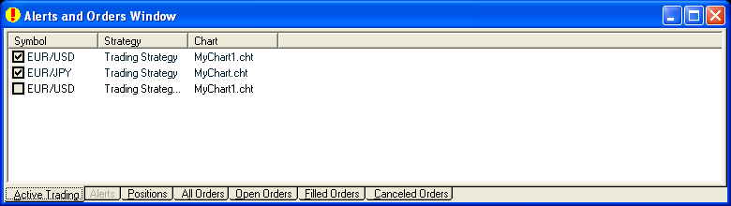

Select the check box to enable the strategy.
Now you are ready to get auto alert from the Neuroshell Trader which will be captured by Trade Pump.

